Diagrams

# Use case diagram.

This diagram describes the WEB app. The design purposes of this app is to provide, store and even help to generate large amount of adaptive music. The simple specification of the actors are written below.

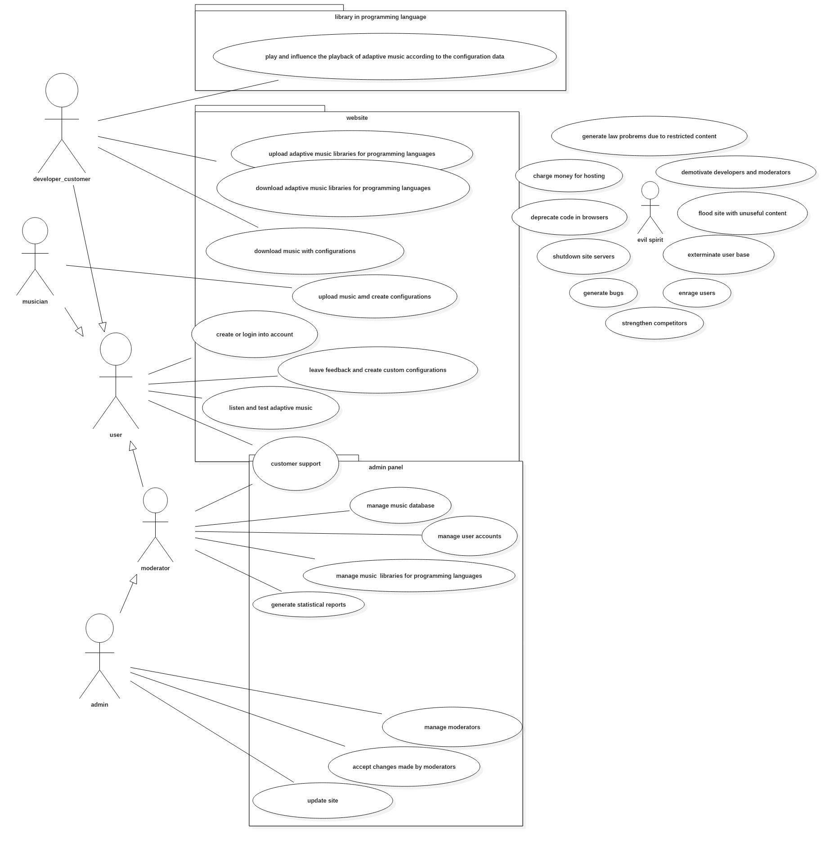

## USER

General user.

Goals:

* Getting to know more about adaptive music.

## MUSICIAN

Content generators.

Goals:

* Creating and uploading adaptive music
* Gaining popularity and reviews
* Making some profit from their creations

## DEVELOPER

Main class of customers.

Goals:

* Find and implement adaptive music in different software solutions.

## MODERATOR

Goals:

* Maintain the site
* Having some revenue

Responsibilities:

* Keeping customer support service alive
* Finding bugs
* Generate statistics

## ADMIN

Goals:

* Keeping everything consistent
* update site
* Manage moderators and their actions

# Activity diagram.

The next diagram resembles the activity of a simple user who is not a developer, manager or musician.

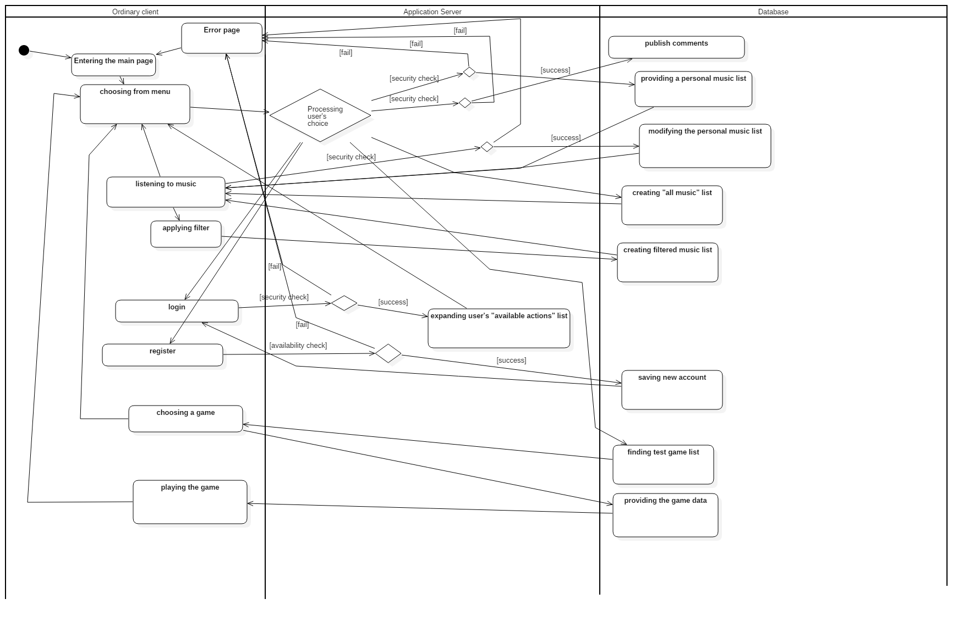

# Class diagram.

This diagram describes the structure of adaptive music container. The functionality includes playing adaptive music. Changing the playback due to the input from outside of the class. A part of class properties and functionality was not shown to provide flexibility to the overall structure (and yes, I know that the general purpose of UMLs is directly opposite).

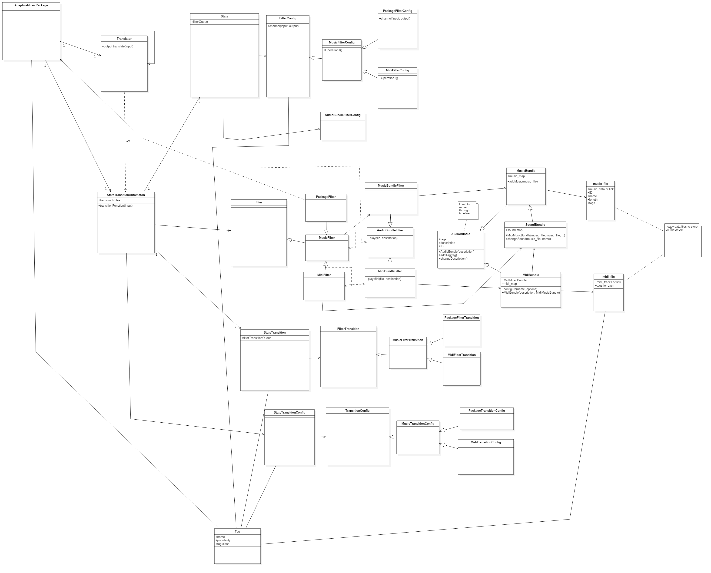

# Object diagram.

This diagram provides an example usage of the class structure described above. Internal properties mostly were not specified due to unimportance.

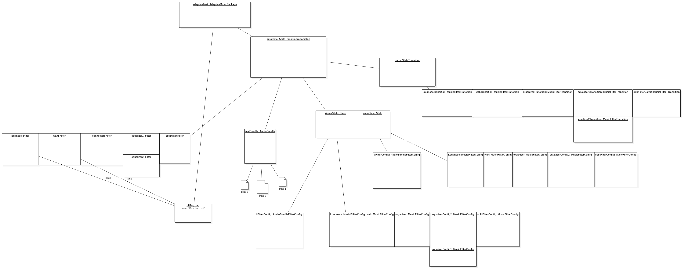

# Statechart diagram.

The simple example of system, shown in use case diagram. Some of the obvious connections were not shown to remain clarity.

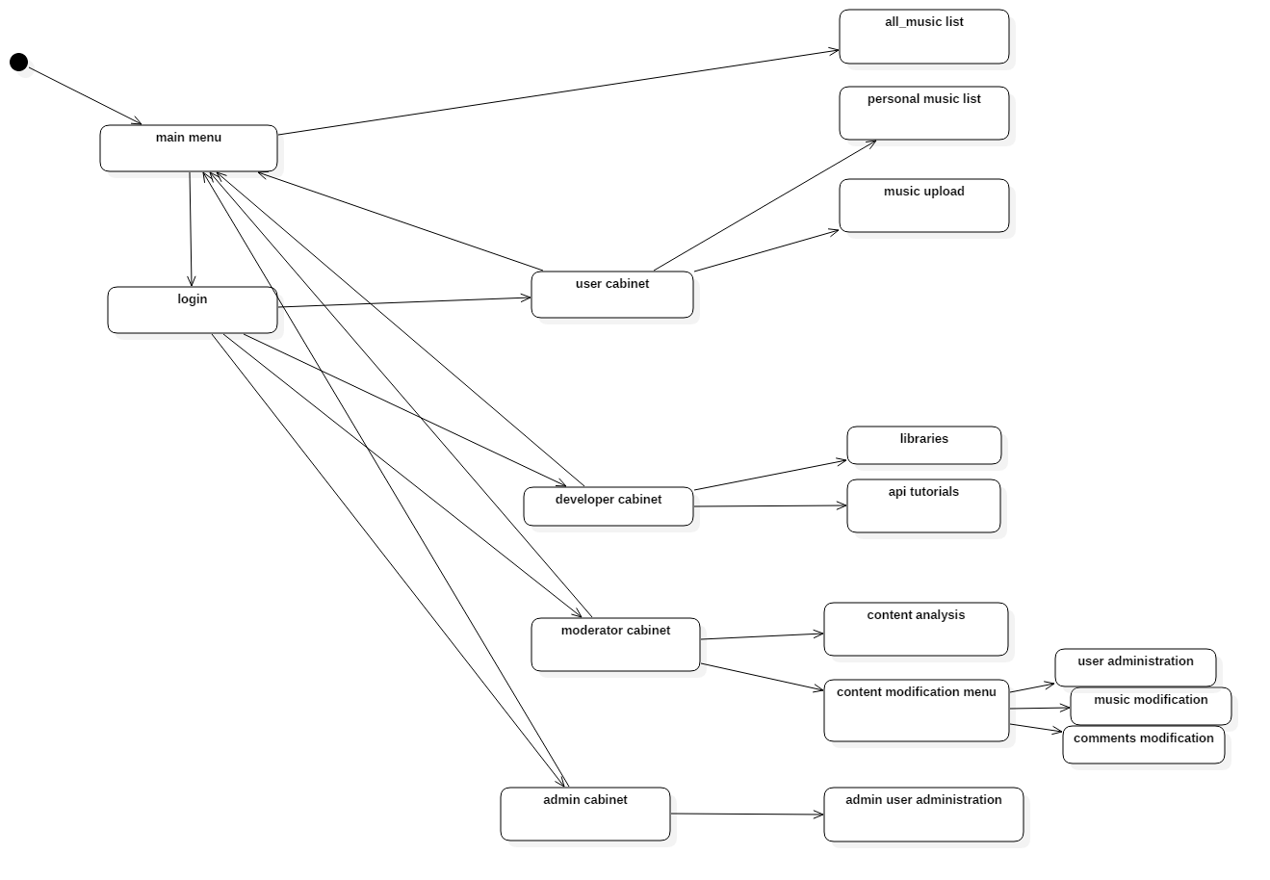

# Sequence diagram.

Description of the adaptive music creational process for clients.

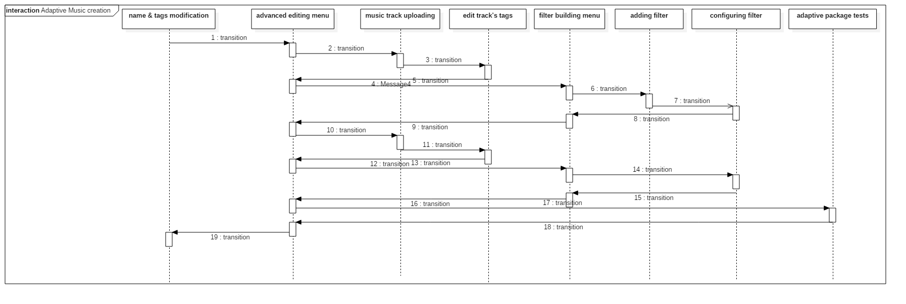

Another one. Shows all of the background communication when the user is trying to load an adaptive music package.

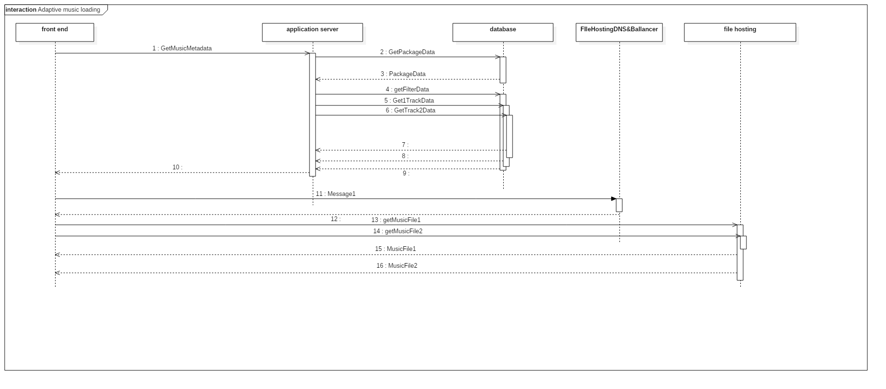

# Communication diagram.

This simple diagram shows the example use of the AdaptiveMusicPackage described earlier to start the playback of an adaptive music composition.

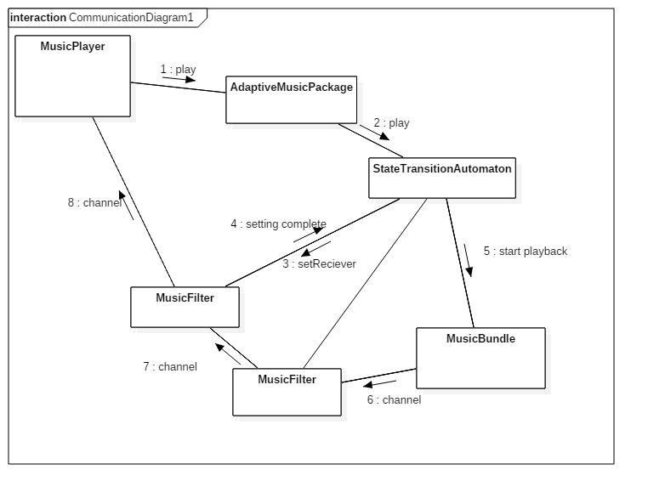

---------------------------------

# Component diagram.

This diagram shows the internal structure of the database.

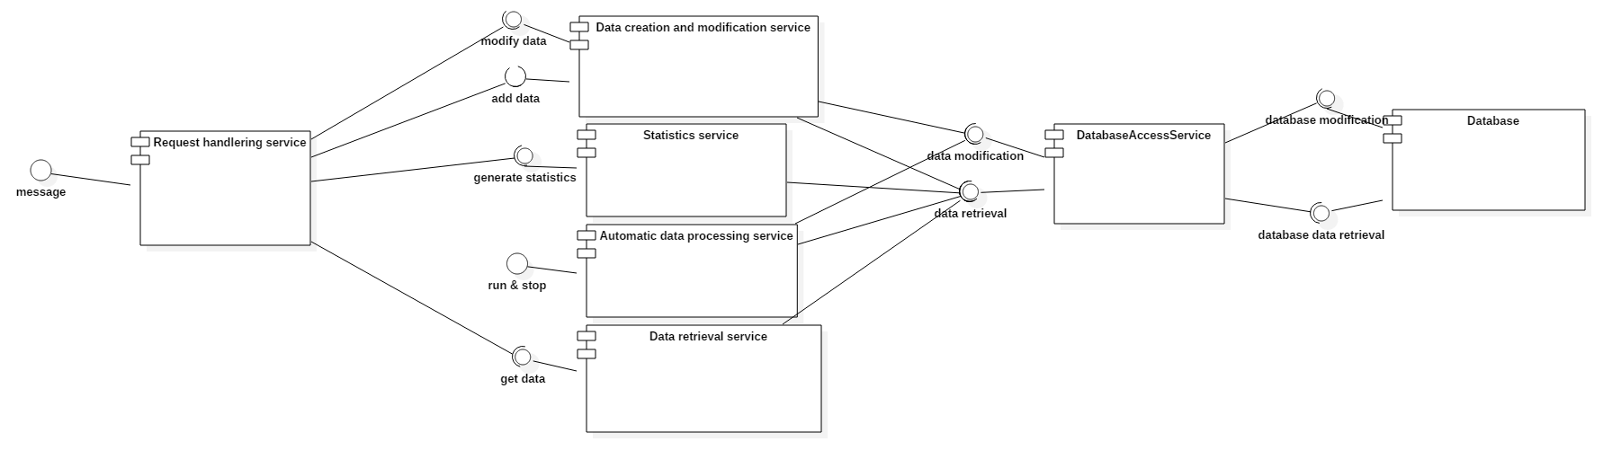

# Deployment diagram.

